Learning Steps |  |  | Description | Link | Learning Objectives
1
2 |  | introduction to Information Security | This chapter presents an overview of information security, with each section getting full treatment in subsequent chapters. We start by exploring the basics of information security | Click Here
3 |  | Watch the video on Introduction of Information Systems
4
5
6 | 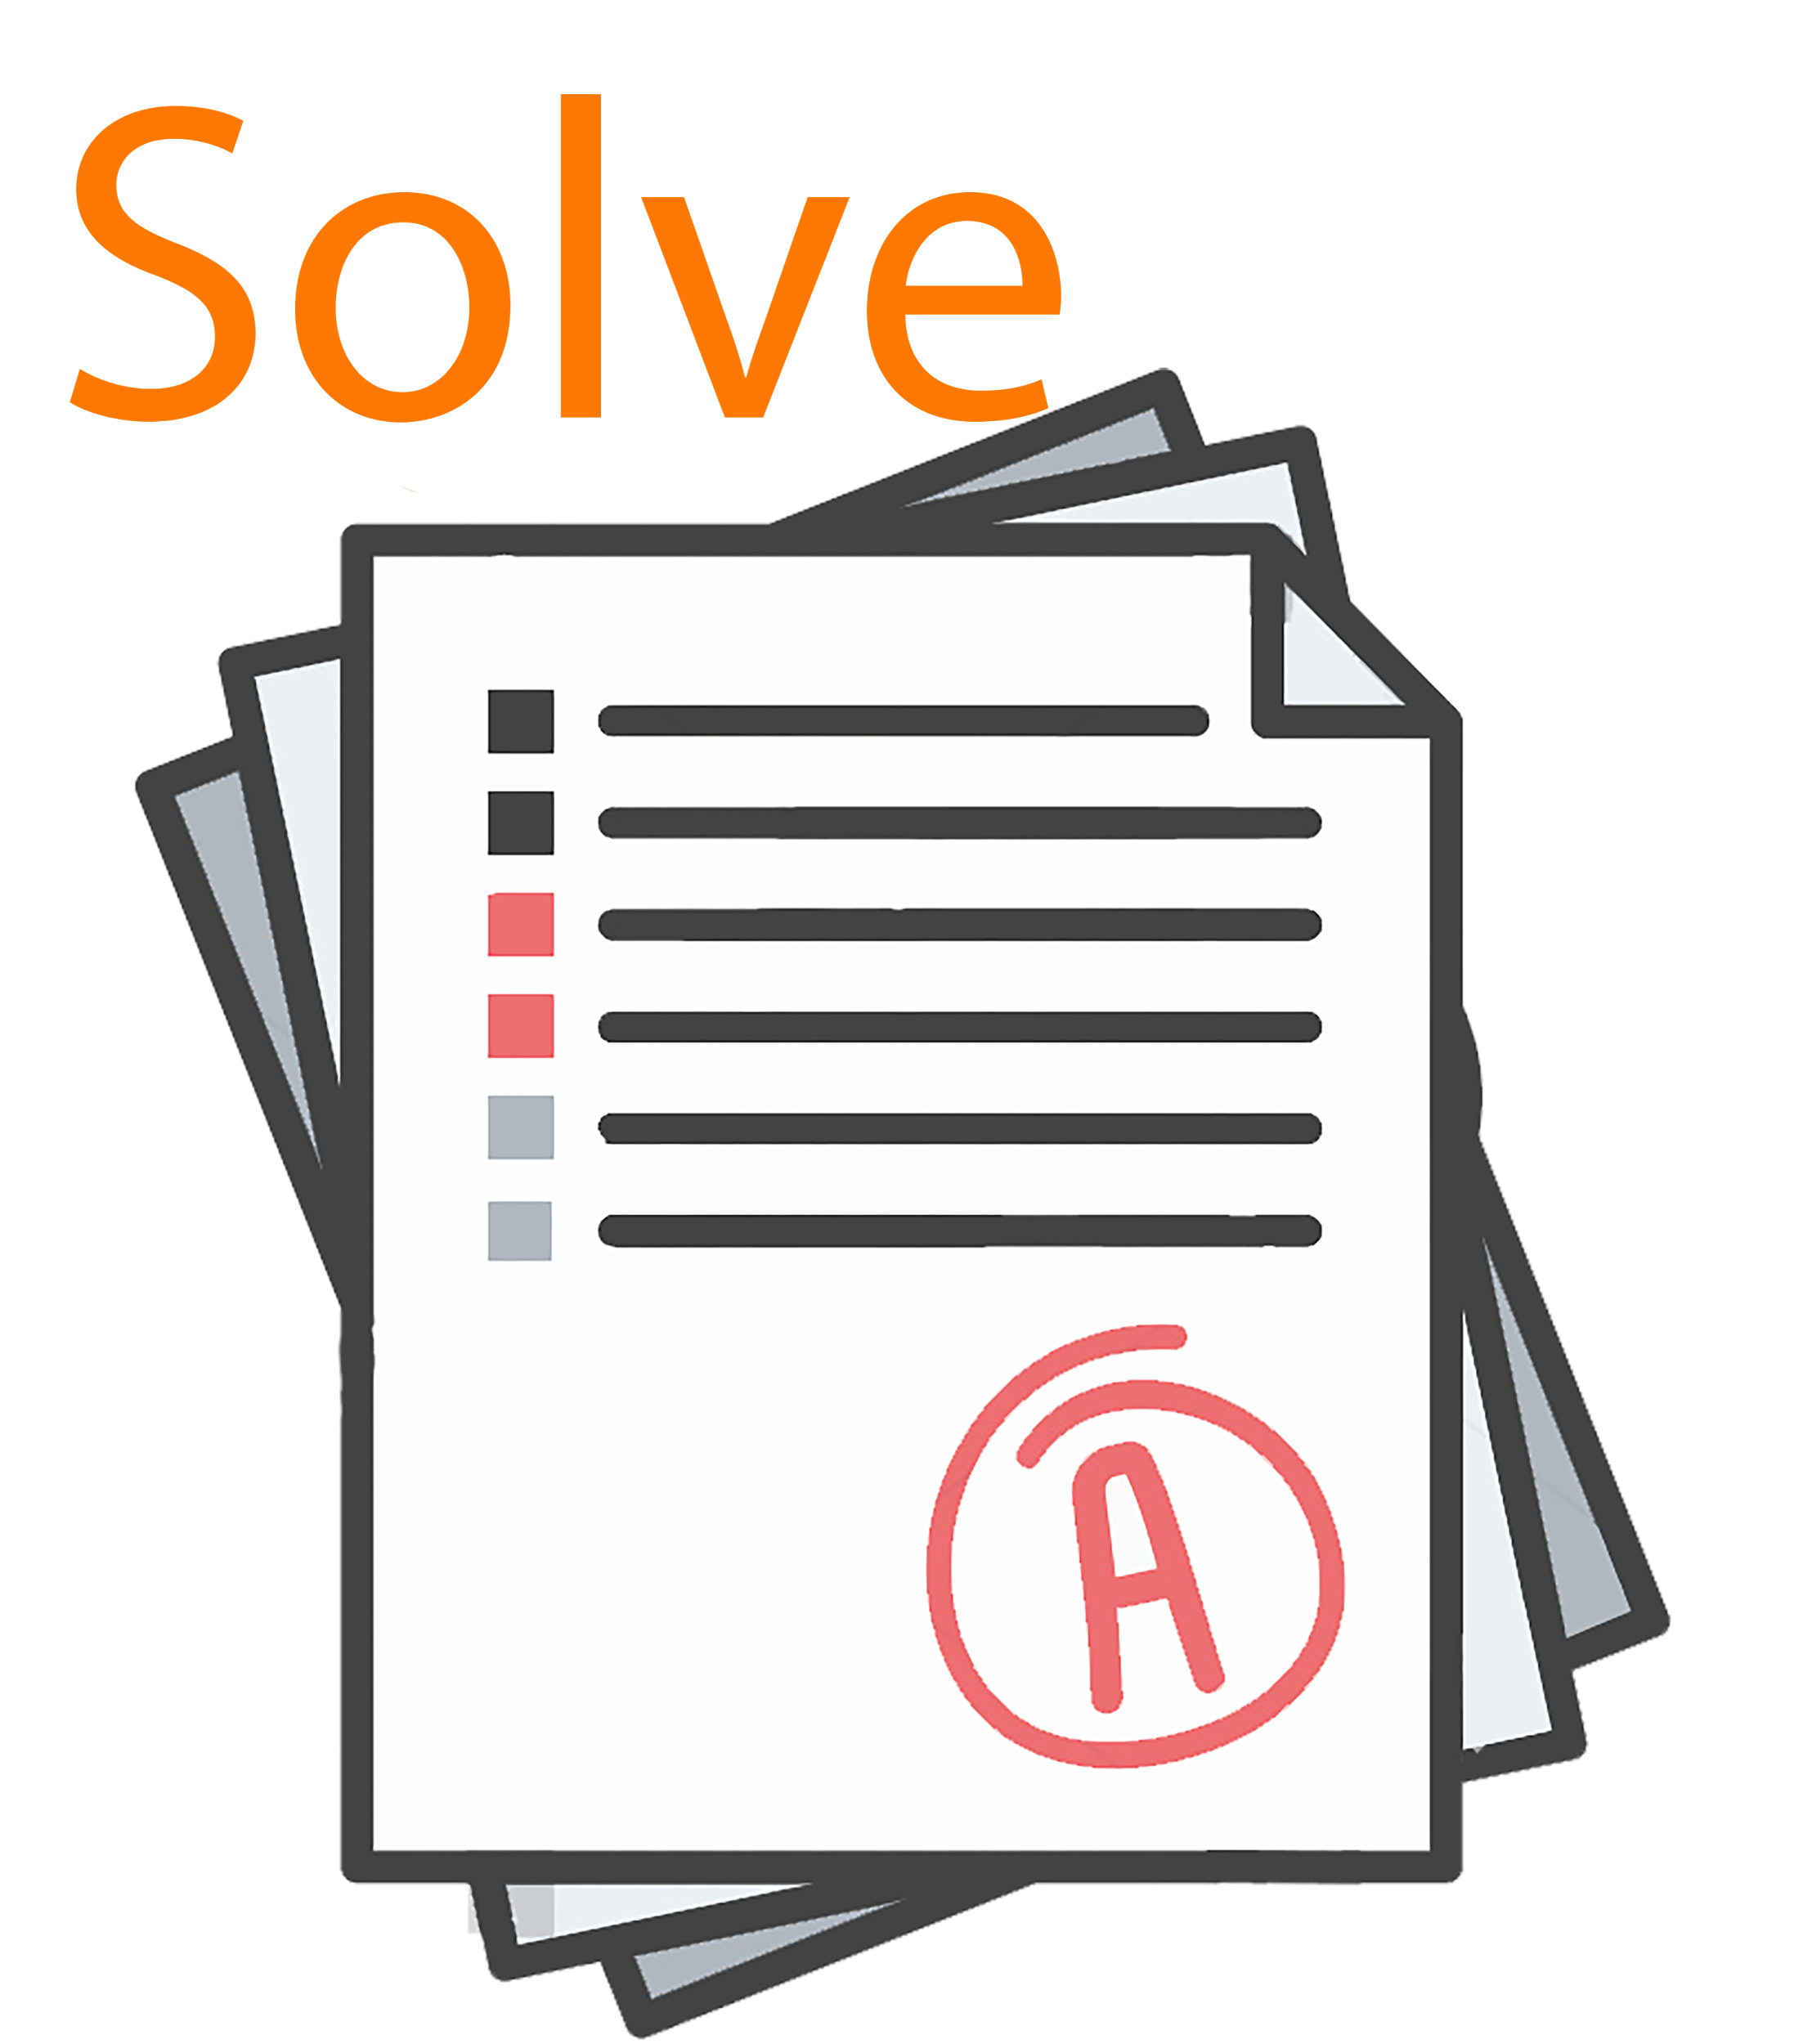
7
8
9

